**Project Report Template**

**Title of Project:** Image Steganography

**Name of the Innovator:** Sindhu K

**Start Date:** 27-10-2025

**End Date: 31-10-2025**

***Day 1: Empathise & Define***

*Step 1: Understanding the Need*

* Which problem am I trying to solve?

I’m solving the problem of **securely hiding confidential text messages** within **image files** to prevent **unauthorized access** or **detection**. Traditional **encryption methods** can expose that a **message** exists, while my project uses the **Least Significant Bit (LSB) steganography technique** to **embed messages invisibly** inside images. To make the process **simple** and **user-friendly**, I’ve integrated an **AI chatbot assistant** that guides users **step-by-step** through **encryption** and **decryption**, ensuring both **security** and **ease of use**.

* Who is affected by this problem?
* How did I find out about this? [Select whichever is applicable]
* Interviews
* Observation
* Online Research
* AI Tools

*Step 2: What is the problem?*

The problem is that **sensitive information** shared digitally is vulnerable to **interception**, **hacking**, or **unauthorized access**. Traditional **encryption methods** can reveal that a **secret message** exists, making them a target for attackers. There is a need for a more **discreet** and **secure** way to **hide confidential data** within **ordinary files** so that its existence remains **undetectable** while still being **easy for users to manage**.

Why is this problem important to solve?

This problem is important to solve because **digital communication** today faces serious threats from **data breaches**, **cyberattacks**, and **unauthorized access**. Protecting **confidential information** has become essential to maintain **privacy** and **security**. By hiding messages within **images** using **steganography**, sensitive data can be shared safely without attracting attention. Additionally, integrating an **AI chatbot assistant** makes this complex process **accessible** and **easy to use** for everyone, promoting **secure communication** in a simple and effective way.

**Take-home task**

Ask 2-3 people what they think about the project:

**1.Student (Computer Science Undergraduate):**  
“I think this project is really interesting because it helps people **protect their private messages** in a smart way. The idea of **hiding text inside images** is cool, and the **AI chatbot** makes it easy even for beginners to use.”

**2.** **IT Professional (Cybersecurity Enthusiast):**  
“This is a **useful and practical project**. Many people don’t realize how easily their data can be exposed online. Using **steganography with password protection** adds an extra layer of **security**, and the **chatbot assistant** makes the process simple and interactive.”

**3. Software Developer (App Developer):**  
“I really like how this project combines **AI and image processing**. It’s a smart solution for **secure communication**, especially for users who don’t know technical encryption. The **step-by-step chatbot guidance** is a great idea to make it **user-friendly**.”

*AI Tools you can use for Step 1 and 2:*

**AI Tools Used:**

1. **Meta MGX**

* Used as a **no-code or low-code development tool** to help design and deploy parts of the **Image Steganography application interface**.
* It supports building **interactive workflows** for encryption, decryption, and image selection processes.
* Ideal for implementing **user interaction flows**, **file upload features**, and **password-based security modules** without extensive coding.

1. **ChatGPT**

* Used for **idea generation**, **content structuring**, and **chatbot dialogue design** to guide users step-by-step.
* Helped in **writing Python scripts** for image processing using **Pillow and Stepic libraries**.
* Also useful for improving the **AI assistant’s responses**, making them more **interactive**, **helpful**, and **user-friendly** during the steganography process.

1. **Chatbot References (Structure Design):**

To design the **AI chatbot assistant**, I referred to:

* **Google Dialogflow** – to understand **intent recognition** and **response flow** for guiding users.
* **IBM Watson Assistant** – for building a **structured Q&A system** to assist with encryption and decryption help.
* **Microsoft Bot Framework** – to study **conversation trees** and **secure user interaction models**.

***Day 2: Ideate***

*Step 3: Brainstorming solutions*

* List **at least 5 different solutions** (wild or realistic):

• **Image Steganography Application** – A Python-based tool that securely hides secret text messages inside image files using the **Least Significant Bit (LSB)** technique.

• **AI Chatbot Assistant for Steganography** – An interactive chatbot that guides users step-by-step through **encryption**, **decryption**, and **password protection** processes to make data hiding simple and user-friendly.

• **Secure Communication Platform** – A desktop or web-based system allowing users to **share hidden data within images** safely, ensuring **privacy and authentication**.

• **Mobile App for Hidden Messaging** – A smartphone application that lets users **send and receive steganographic images**, integrated with **password-based access** and **AI chatbot support**.

• **Educational Steganography Simulator** – A learning platform where students can **experiment with steganography techniques**, visualize how data is hidden inside images, and understand the importance of **digital security**.

• **StegoAI Suite** – A complete **AI-powered steganography toolkit** built using **Meta MGX** and **ChatGPT**, combining **image encryption**, **password security**, and **chatbot guidance** for secure and easy data protection.

Step 4: My favourite solution:

My favorite solution is **StegoAI**, a complete **AI-powered Image Steganography application** designed for **secure communication**. It combines the **Least Significant Bit (LSB)** technique to hide secret messages inside images with an **AI chatbot assistant** that guides users through encryption and decryption steps. Built using **Meta MGX** and **ChatGPT**, it ensures both **security** and **ease of use**, allowing anyone to protect their confidential information effortlessly. This makes StegoAI a **practical, user-friendly, and impactful** solution for maintaining **digital privacy** in everyday communication.

Step 5: Why am I choosing this solution?

I am choosing **StegoAI** because it combines **AI chatbot assistance** with **image steganography** to provide a simple yet powerful solution for **secure communication**. It allows users to **hide confidential messages** inside images using the **LSB technique** while maintaining **ease of use** through an interactive chatbot. The integration of **Meta MGX** and **ChatGPT** makes it efficient, accessible, and user-friendly, ensuring that anyone can protect their data without needing advanced technical skills.

AI Tools you can use for Step 3-5:

**AI Tools for Step 3–5**

**1.**  **Meta MGX**  
• Used to design the **StegoAI interface** without coding.  
• Helps build **interactive workflows** for encryption, decryption, and password security.

**2.** **ChatGPT**  
• Used for **idea generation**, **Python code assistance**, and **chatbot conversation design**.  
• Helps create clear **user prompts** and improve chatbot interaction.

**3.** **AI Chatbot References**  
• **Dialogflow** – For **intent detection** and **response flow**.  
• **IBM Watson Assistant** – For **structured Q&A** design.  
• **Microsoft Bot Framework** – For managing **conversation logic**.

**4.** **AI Research Tools**  
• **Google Scholar / Research AI** – For studying **steganography methods**.  
• **AI Summarization Tools** – For refining and presenting **project ideas** clearly.

AI Tools you can use for the take-home task:

**Canva AI / Meta AI / Copilot AI** – create visuals, **ChatGPT** – generate and summarize feedback, **Gemini** – refine responses, **Grammarly / QuillBot** – polish text, **Notion AI** – organize and present reports.

***Day 3: Prototype & Test***

*Step 6: Prototype – Building my first version*

What will my solution look like?

* **Home Screen:** Welcomes the user with options to **upload an image**, **enter a secret message**, and **set a password**.
* **AI Chatbot Assistant:** An interactive chat window that **guides users step-by-step** through encryption and decryption processes.
* **Encryption Screen:** Allows users to **hide text inside images** using the **LSB steganography technique** and save the encoded image securely.
* **Decryption Screen:** Lets users **upload an encoded image**, enter the **correct password**, and **reveal the hidden message**.
* **Help & Info Section:** Provides **tips, FAQs**, and **security guidelines** about safe data sharing and steganography.

**Design Style:**

* Simple, **clean, and user-friendly** interface.
* **Dark mode** theme for better visual focus on images.
* **Interactive chatbot layout** for smooth user experience on desktop or mobile.

**Prototype Tools:**

* Built using **Meta MGX** for interface design and **ChatGPT** for chatbot conversation flow and guidance.

What AI tools will I need to build this?

**AI Tools Needed to Build CareerPath**

1. **Meta MGX**
   * No-code platform to **design and deploy the app**.
   * Allows building **interactive screens, chat interfaces, and skill modules** without coding.
2. **ChatGPT (or similar LLMs)**
   * To **generate content, conversation flows, and career guidance responses**.
   * Can help **personalize recommendations** for users based on their profile and location.
3. **AI Chatbot Design References**
   * **Google Dialogflow / IBM Watson Assistant / Microsoft Bot Framework**
   * To **structure conversation logic** and handle user queries effectively.
4. **AI Recommendation Tools** *(Optional but useful)*
   * For **matching students with careers, scholarships, and nearby opportunities**.
   * Could use **ML-based ranking algorithms** or **existing AI APIs** for personalization.
5. **AI Data Analysis Tools** *(Optional for insights)*
   * **Python AI libraries (Pandas, Scikit-learn)** or **AI analytics platforms**
   * To analyze user interactions and improve recommendations over time.

What AI tools I finally selected to build this solution?

1. **Chat GPT**
2. **Metamgx**

**< Build The Innovation>**

**<DASHBOAD OF THE TOOL>**

**Tool Link:**  <https://mgx-xm3nuxq57xe.mgx.world>

**Figure 1: Initial Interface of the Image Steganography Application**

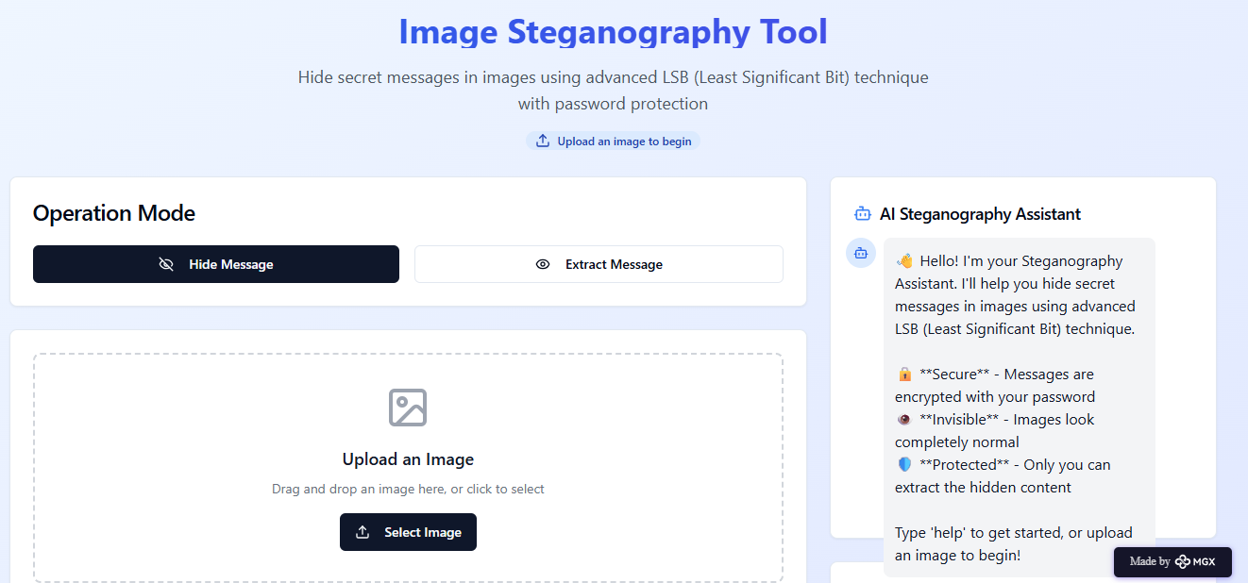

**Figure 2: Image Upload Interface of the Steganography Application**

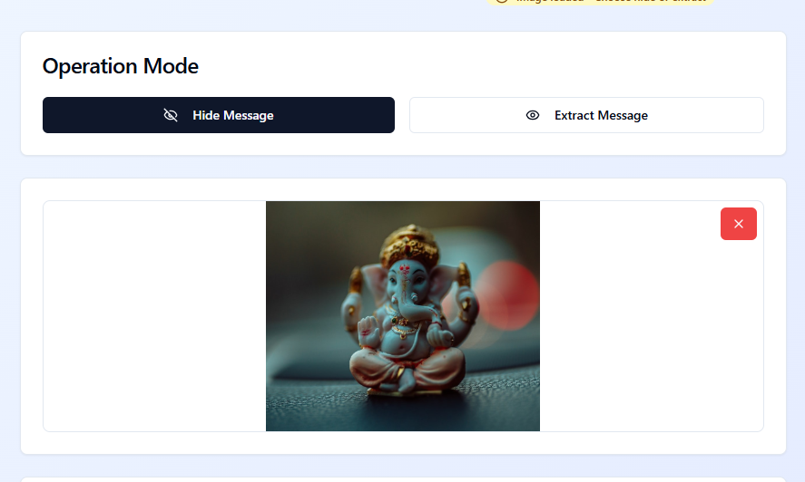

**Figure 3: Entering the Secret Message and Password for Encryption**

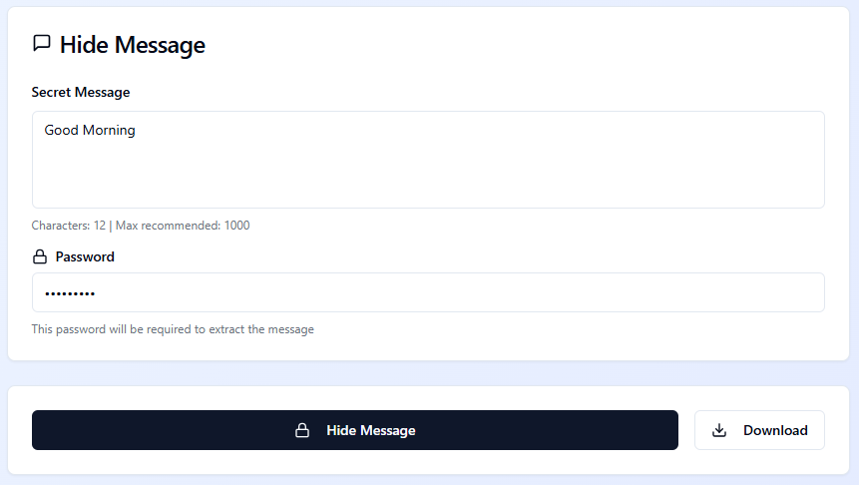

**Figure 4: Downloading the Encrypted Image**



**Figure 5: Selecting the ‘Extract Message’ Option**

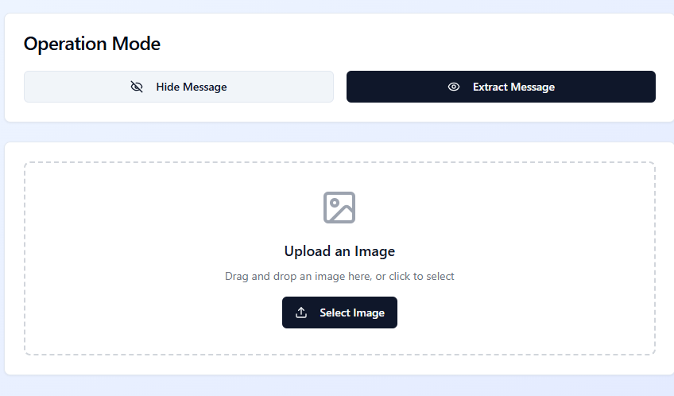

**Figure 6: Uploading the Encrypted Image for Decryption**

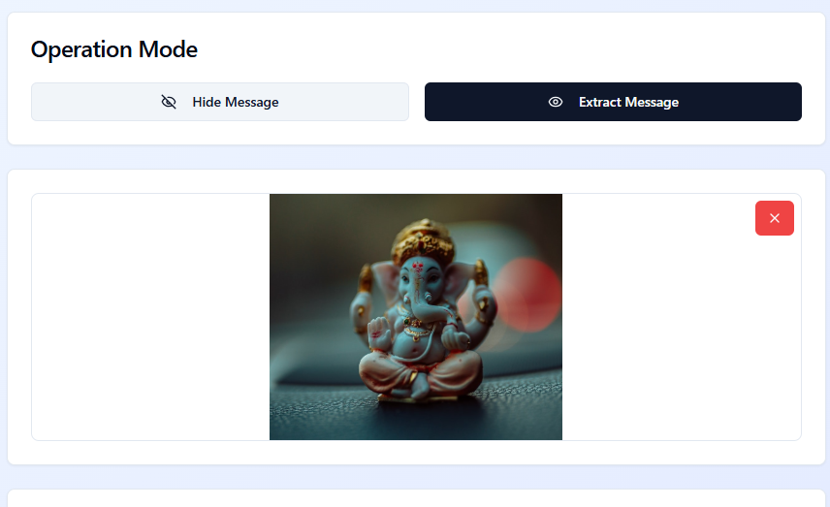

**Figure 7: Entering the Password for Decryption**

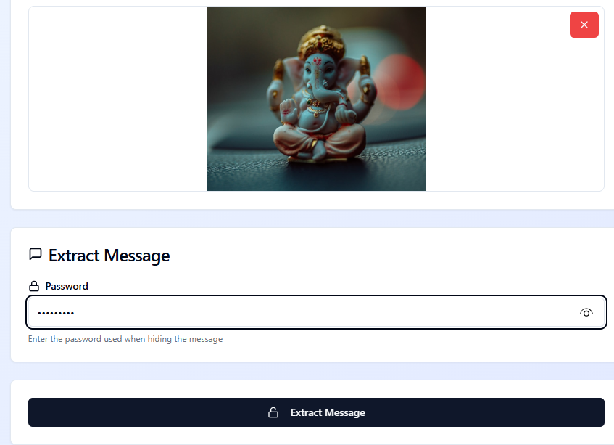

**Figure 8: Displaying the Decrypted Secret Message**

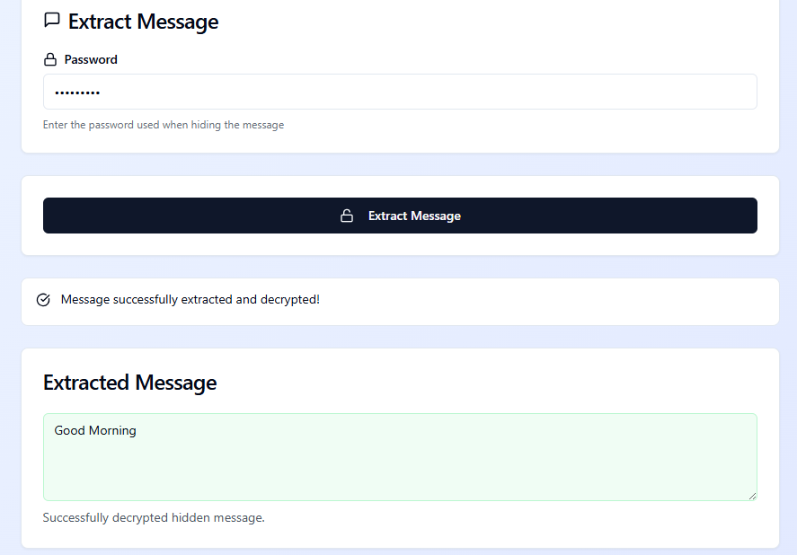

**Figure 9: Integrated AI Chatbot — The Steganography Assistant**

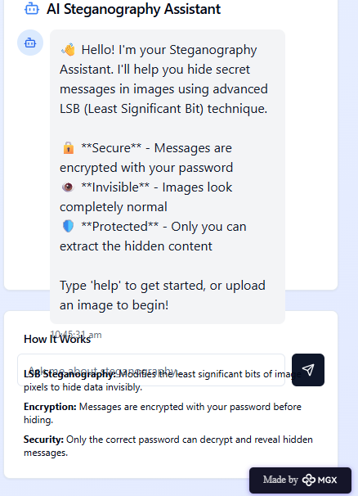

* Who did I share my solution with?

**I shared my Image Steganography with Ai Chatbot Assistant solution with:**

* **Fellow computer science students** – to gather feedback on usability, interface design, and ease of encryption/decryption.
* **Faculty mentors and project supervisors** – to evaluate the technical implementation, accuracy of the LSB algorithm, and chatbot performance.
* **Cybersecurity enthusiasts and peers** – to assess the strength of the password-based protection and data confidentiality.
* **Non-technical users** – to test how effectively the AI chatbot assists beginners in performing steganography without prior technical knowledge.
* **Friends and classmates** – for overall feedback on the user experience, visual appeal, and system functionality.

What feedback did I receive?

**Feedback: Pros and Cons**

**Pros (Positive Insights from Feedback):**

* **User-Friendly Design:** Reviewers appreciated the simple and intuitive interface, especially with the chatbot’s step-by-step guidance.
* **Effective Security Integration:** The password-based encryption and decryption were found to enhance data privacy and message protection.
* **Practical and Innovative Concept:** Combining AI assistance with image steganography was praised as a creative approach that simplifies a complex process for users.

**Cons (Areas to Improve Noted in Feedback):**

* **Limited File Format Support:** The application currently supports only specific image formats (e.g., PNG), which restricts broader usability.
* **Processing Time:** Encryption and decryption processes can be slightly slow for larger image files.
* **Basic Chatbot Intelligence:** The chatbot’s responses are rule-based and could be improved to handle more dynamic or context-aware interactions.

**My Response for The Feedback:**  
I was encouraged by the positive feedback highlighting the **user-friendly interface**, **secure encryption process**, and **innovative use of an AI chatbot**. Based on the suggestions, I plan to **expand the application’s compatibility** to support more image formats, **improve the efficiency** of encryption and decryption for larger files, and **enhance the chatbot’s intelligence** to provide more natural, context-aware assistance in future versions.

👍 What works well:

**What Works Well**

• **Seamless Image Encryption and Decryption:** The application efficiently hides and retrieves secret messages using the **Least Significant Bit (LSB)** technique without affecting image quality.

• **AI Chatbot Assistance:** The **integrated chatbot** provides step-by-step guidance throughout the process, making complex cryptographic operations simple for users.

• **User-Friendly Interface:** A **clean and intuitive design** ensures that both technical and non-technical users can easily navigate the system.

• **Password-Protected Security:** The inclusion of a **password-based access system** ensures that only authorized users can decrypt hidden messages, enhancing data confidentiality.

• **Local System Operation:** The tool works **offline on a local machine**, ensuring privacy and security without relying on external servers.

• **Educational and Practical Value:** Demonstrates the **real-world application of cybersecurity and AI integration**, useful for students and research projects.

🔧 What needs improvement:

• **Limited File Format Support:** Currently, the system primarily supports **PNG images**; expanding compatibility to formats like **JPEG and BMP** would increase flexibility.

• **Chatbot Intelligence:** The chatbot operates on **rule-based responses**; enhancing it with **natural language processing (NLP)** could make interactions more dynamic and context-aware.

• **Processing Speed:** The **encryption and decryption times** can be optimized, especially for large image files, to improve efficiency.

• **Error Handling and Notifications:** More **user-friendly alerts and error messages** could help users better understand issues during encryption or decryption.

• **User Interface Enhancements:** Adding **visual indicators or progress bars** during operations would make the user experience smoother and more informative.

• **Advanced Security Features:** Implementing **multi-layer encryption** or **key management options** could further strengthen data protection.

*AI Tools you can use for Step 6-7:*

**ChatGPT/Perplexity AI/Claude AI/Canva AI/Chatling AI/Figma AI/Metamgx/Gamma AI**: You can use these tools to build solutions/models or mock-up dummy prototypes

***Day 4: Showcase***

*Step 8: Presenting my Innovation:*I am presenting **Image Steganography with AI Chatbot Assistant**, a secure communication tool that hides secret messages inside images using the **Least Significant Bit (LSB)** technique. The built-in **AI chatbot** guides users through image selection, encryption, and decryption with a simple and intuitive interface.

• **AI Chatbot Support** for step-by-step user guidance.  
• **Password-Protected Encryption** ensuring message security.  
• **User-Friendly and Offline Application** for privacy and ease of use.

**Impact:** This innovation enhances **digital security awareness** and makes **steganography accessible** to all users through an interactive AI-driven experience.

*Step 9: Reflections*

* What did I enjoy the most during this project-based learning activity?
* I enjoyed **integrating AI with image steganography**, as it allowed me to explore both creativity and technical innovation. Building the **AI chatbot assistant** was particularly satisfying because it made complex encryption and decryption tasks easy for users to understand. I also enjoyed **testing the system’s functionality** and seeing how my project could provide a secure and interactive communication experience.

What was my biggest challenge during this project-based learning activity?

My biggest challenge was **integrating the AI chatbot with the image steganography system** while ensuring smooth interaction and accurate functionality. It was difficult to **maintain synchronization between the chatbot’s guidance and the encryption–decryption processes**. Additionally, managing **image quality preservation during message embedding** and optimizing the performance for larger files required extensive testing and debugging.**Take-home task.**

<https://github.com/sindhukece2026-prog/Image-Steganography>

*AI Tools you can use for Step 8:*

**Canva AI:** You can use this to design your pitch document. Download your pitch document as a PDF file and upload on GitHub